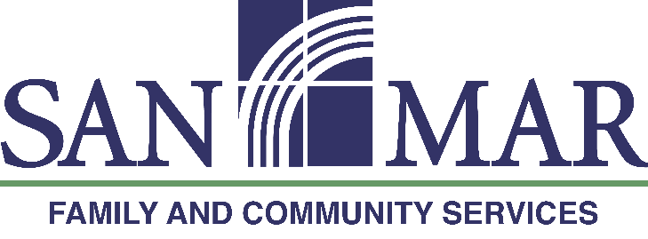
Community Event Press Release
Contact Information
San Mar Family and Community Services
Keith Fanjoy, CEO
301-733-9067

FOR IMMEDIATE RELEASE
San Mar Family and Community Services Celebrates
Success of The Great Bicycle Tour (TGBT XXXIV)

Boonsboro, MD, July 30, 2021 – San Mar announces successful completion of the 34th edition of The Great Bicycle Tour of the C&O Canal

San Mar Family and Community Services held the 34th edition of its largest annual fundraiser, The Great Bicycle Tour (TGBT) of the C&O Canal July 10-13, 2021. The 184.5-mile tour begins in Cumberland, MD and follows the C&O Canal Tow Path for four days, ending at mile marker 0 in Washington, D.C. More than 120 riders joined this fundraiser to support children, families and communities in the region served through San Mar’s key programs including Treatment Foster Care, The Bester Community of Hope and The Jack E. Barr Center for Well-Being. The ride is fully supported over the course of four days of cycling, with meals, lodging, and transportation included.

Rider fundraising has netted $105,769 so far, with a few weeks remaining to collect additional donations through rider giving pages. Sponsorship underwriting which helped make the ride possible, was received from presenting sponsor The Nora Roberts Foundation, lead sponsors The Loats Foundation, Staples Mid-Atlantic Distribution Center, Middletown Valley Bank, Bitner Henry Insurance Group, SEK CPAs & Advisors, and partnering sponsors Meritus Health and Younger Toyota. Additional support was received from Conagra Brands, Keller Stonebraker/Blue Ridge Risk Partners and a variety of local organizations including Hagerstown Ford and Lions Club chapters from Boonsboro, Hagerstown, and Hancock.

In the 30+ years of hosting this bicycle tour, San Mar has raised well over one million dollars in support of its programs serving children and families. Donations are still gratefully accepted at www.sanmartgbt.org
Registration for next summer’s bicycle tour will open November 1, 2021 and TGBT XXXV will take place
July 9-12, 2022.

" I had the best time on the ride. It was just what I needed! I was able to raise money for such a great cause and I made some great friends. The only problem with the ride was it was only 185 miles and not 250. We all did not want it to end. I will be back next year. I am honored to be part of this and be a small part of San Mar’s success.” – Mark Bindon (first-time TGBT participant)

San Mar Family and Community Services, whose mission is “Cultivating Hope and Well-Being in Children, Families and Communities” has been serving the Washington County, Maryland area since 1883. Services are provided through San Mar Treatment Foster Care, the Jack E. Barr Center for Well-Being outpatient mental health services, and Bester Community of Hope prevention programs.

Media inquiries and event questions - Contact Elisa Hermes at ehermes@sanmarhope.org
Media Kit is available at https://sanmartgbt.org/about/media-kit/

###

